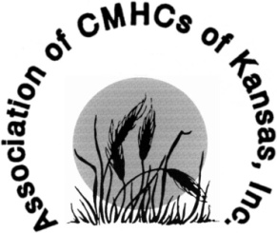
Annual Conference for Behavioral Health
September 11 – 14, 2018
Manhattan, KS

Exhibitor Form

Company/Agency Name: Click here to enter Company/Agency Name

Company/Agency Contact: Click here to enter contact Person’s Name

Company/Agency Address: Click here to enter Street Address
Click here to enter Suite #
Click here to enter City
Click here to enter State
Click here to enter Zip Code

Contact Phone Number: (Area Code) Phone Number

Email Address: Click here to enter Contact Person’s Email Address

Company/Agency Website:

Exhibitor Level: ☐$250 Non-Profit

☐$650 For-Profit

Do you require electricity for your Exhibit Booth? ☐Yes ☐No
Additional costs may be required for electricity.

Please send completed Exhibitor Form to helliott@acmhck.org.

Please send check payable to:
Association of Community Mental Health Centers of Kansas
534 South Kansas Avenue, Suite 330
Topeka, KS 66603-4451

