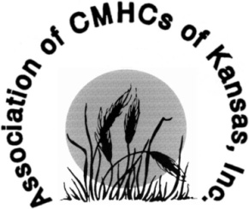
Annual Conference for Behavioral Health
September 11 – 14, 2018
Manhattan, KS

Sponsorship Form

Company/Agency Name Company/Agency Name

Company/Agency Contact Contact Person’s Name

Company/Agency Address Street Address
Suite #
City State Zip Code

Contact Phone Number (Area Code) Phone Number

Email Address Contact Person’s Email Address

Company/Agency Website website

Sponsorship Level ☐ $10,000 Platinum
☐ $5,000 Gold
☐ $3,000 Evening Reception
☐ $3,000 Golf Tournament
☐ $2,500 Refreshment Break
☐ $2,500 Silver
☐ $1,000 Bronze

Please send completed Sponsorship Form to helliott@acmhck.org.

Please send check payable to:

Association of Community Mental Health Centers of Kansas
534 South Kansas Avenue, Suite 330
Topeka, KS 66603-4451

